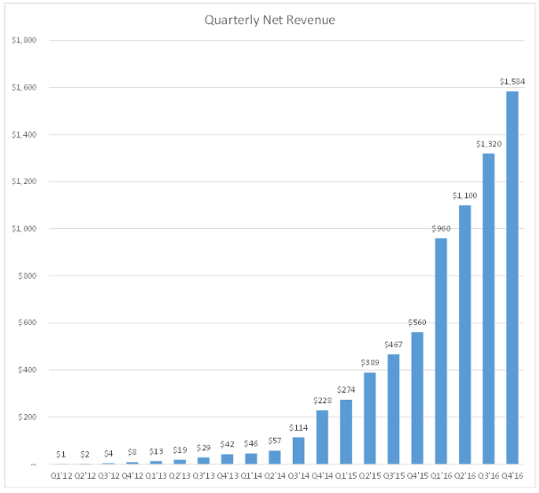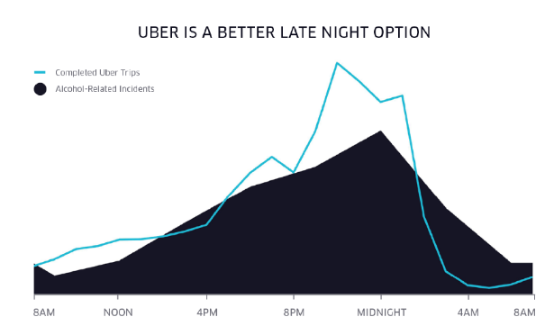

\*Worth of Uber is between 68B-70B last year

\*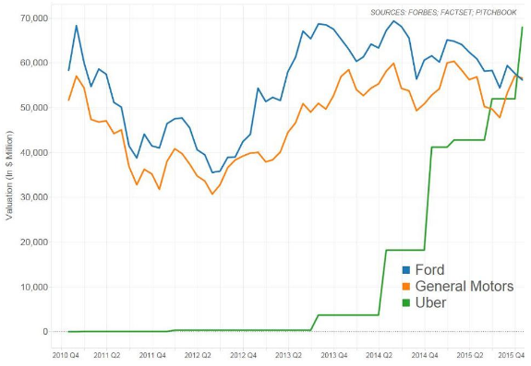Q1 of 2016 the revenue increased by 400M

\*Q2 of 2016 the revenue increased by 140M

\*Q3 of 2016 the revenue increased by 220M

\*Q4 of 2016 the revenue increased by 264M